Tenda MW5s-How to set wired backhaul connection?

User Scenario: Many obstacles or Cement walls in using environment. Connect with each node one by one by ethernet cable to reduce the loss of wireless transmission.

Step 1: Add all nodes into a same mesh network system. Please refer to the picture.
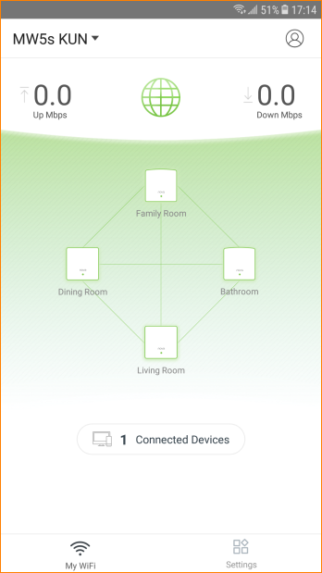

Step 2: Connect with each node one by one by ethernet cable.
E.g: Connect with primary node’s LAN port with second node’s WAN/LAN port by cable.

Note: If set wired backhaul connection, WAN/LAN ports of all nodes are used as WAN port.

